Talking Mats for Reflecting and Managing Clinical Progress on Placement

Talking Mats is an interactive resource that uses three sets of picture communication symbols – topics, options and a visual scale – and a space on which to display them. Once the topic is chosen e.g., ‘activities’ or ‘people’, the participant is given the options one at a time and asked to think about what they feel about each one. They can then place the symbol under the appropriate visual scale symbol to indicate what they feel [(Talking Mats, 2019)](https://www.talkingmats.com/about/our-resources/). It is often used in research across the lifespan and different abilities e.g. Aphasia, Learning Disability, Autism, Brain Injury, Dementia, for clients to be able to give their opinion and have their voices heard.

Therefore using Talking Mats as part of the process of supervision for Speech and Language Therapy Students is a good exercise to both practise the use of a tool that may be used with clients, but also as a tool for placement students to reflect on their progress and highlight any areas they have found harder/are less confident in. This may be used pre, mid and post placement so the student can see/reflect on their progress or used as a one off during placement to compliment the feedback and reflective process. Here is how I use Talking Mats with my placement students, including a free download to the resources I use!

As someone who has had the privilege of attending the training, I highly recommend checking out these [training opportunities](https://www.talkingmats.com/training/foundation/) (it is one of my top 5 CPD events I have attended in my professional career). If you are new to Talking Mats this is quite important to ensure you understand how Talking Mats work!

***Process:***

*Materials:*

* Mat: this can be a large sheet of paper or even a doormat!
* Cards (Following page) cut out
* Post it notes
* Pen

*What to do using Talking Mats Principles*

1. Introduction: ‘we are going to talk about how you are finding the placement using Talking Mats’ (Place Topic Card: Clinical Progress on Placement)
2. Introduce top Scale: Let the student choose: Going well, Going Ok, Not going well: Really confident, confident, not very confident: Happy with, Ok with, Unhappy with.
3. Give each card to the student to place where they feel appropriate: use open questions to encourage expression when handing the cards to them e.g. ‘how do you feel about X?’Do not ask questions regarding their answers, but you can repeat back what they say ‘that’s going well is it?’ Non Verbal Communication: Mmmhmmm.

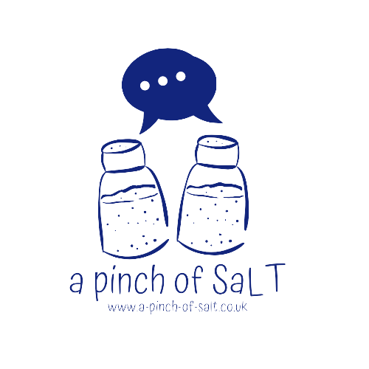

1. When the cards are finished, ask the student if there is anything else they would like to add (use the post notes and pens if needed).
2. Check and change: Recap what they have said, starting from negative to positive. Give time for them to change or rearrange anything, allow any issues/difficulties/further discussion to emerge.
3. Record and agree any action points

**Further Information**

<https://www.talkingmats.com/>



| Person Centred Therapy | Goal Setting | Gathering appropriate information from different sources | Building rapport with the client(s) |
| --- | --- | --- | --- |
| Organisation | Taking Data | Liaising with others | Feeding back to others regarding client |
| Administrative Tasks | Modifying goals and sessions according to client performance | Engaging in professional discussion about clients | Flexibility |
| Case notes | Administering assessments (formal and informal) | Reflecting on own performance | Training others |
| Working as part of an MDT team | Making hypothesis | Using initiative | Evidenced Based Practise |
| Planning intervention incl session plans | Drawing conclusions | Delivering intervention | Report writing |

Six general areas of performance are considered: observation and assessment, planning intervention, delivery of intervention, professional communication skills, clinical responsibility and self – appraisal and personal development.

| **Topic: Clinical Progress on Placement** |
| --- |

**Different Top Scales**

| File:Emoji face rating scale.png | File:Emoji face rating scale.png | File:Emoji face rating scale.png |
| --- | --- | --- |

Images from: <https://commons.wikimedia.org/wiki/File:Emoji_face_rating_scale.png>

|  |  |  |
| --- | --- | --- |

Images from: <https://commons.wikimedia.org/wiki/File:Black_bordered_yellow_star.svg>